Moon Phases to Predict Human Behaviour

Renato Francisco Goedert
Waterford, Ireland
renato.goedert@gmail.com

^{17th} December 2025
Abstract— This study aims to leverage a project realized for the module of Programming for Artificial Intelligence, where public datasets were used to investigate a correlation between crimes and moon-phases, to demonstrate the author capacity for data analysis and technical writing. The public datasets used for this study is the Chicago Crimes Datasets and the NASA moon-phases dataset from the years of 2020 to 2025; Data ingestion, preprocessing, and exploratory analysis were conducted using Python-based tools, including Pandas, NumPy, and Seaborn. Machine learning models implemented with the Scikit-learn library were applied to evaluate potential predictive relationships between crime frequency and lunar phases.. The results strongly demonstrated that no significant statistics were found between the Chicago Crimes dataset and the NASA Moon Phases dataset, further debunking this cultural myth.
Keywords— Moon, Crimes, Chicago, NASA, Datasets, Artificial Intelligence, AI Models, Analysis

Introduction
Human societies have long speculated about connections between human behaviour and the astronomical phenomena, with the existence of a common cultural belief suggesting that full moons may increase crime, accidents, or other unusual events. Although scientific evidence for such effects is limited, a few studies have identified small but notable behavioural fluctuations associated with lunar phases [1], [2].
In parallel, the availability of large-scale public datasets, along with advances in computational power and analytical methods, has improved significantly in recent years. This progress is reflected in the growing number of studies analysing the influence of temporal, environmental, and socio-contextual factors on crime incidence, including time of day, seasonality, and neighbourhood characteristics[3] [4].
Despite extensive research on modelling crime, utilization of astronomical data-such as Moon phases-is extremely rare. This lays out the setting for a novel investigation.
The present project integrates two datasets to explore this.
- Chicago crime records
- NASA lunar phase data
These datasets proceed to be processed through a Python-based pipeline, which involves programmatic retrieval, preprocessing, transformation, and later storage on the local database. The combined data are then analysed to examine whether lunar phases correspond with measurable variations in crime patterns, thereby aligning with the study objectives.

related work
Research into the effects of lunar phases on human behaviour has yielded inconsistent results: some studies claim that a full moon has no significant effect on either psychological or behavioural patterns; other studies indicate small, yet detectable, fluctuations. For instance, Owen [1] reported small-scale behavioural disturbances linked to certain phases of the moon, while Raison et al. [2] concluded that most of the observed effects were statistically insignificant. Overall, evidence from scientific research implies very weak or non-uniform correlations.
On the other hand, crime analysis research has widely considered temporal, environmental, and socio-contextual factors. Ratcliffe [3] remarks that systematically varying features in daily routine, seasonality, and neighbourhood characteristics may explain variations in crime magnitude. The latter studies typically use structured datasets and statistical modelling, with only a few considering astronomical variables; thus, the effect of lunar cycles is still largely unexamined.
As a result, existing research has largely treated crime modelling and lunar influence studies as separate domains. The lack of integrated analyses combining crime data with lunar phase information reveals a gap in the literature that this study seeks to address.

Methodology
For this study a straightforward architecture was applied. The data processing pipeline was implemented using Python; NumPy and Pandas for the numerical calculations and manipulations; Seaborn for graphical analysis; Scikit-Learn library for AI models evaluation.
The Chicago and NASA datasets were retrieved via a Python-based data ingestion script, which also executed all data wrangling operations, including preprocessing, data cleaning, normalization, and schema alignment.
Following preprocessing, the resulting structured datasets were persisted in a containerized PostgreSQL relational database and deployed using Docker, which ensures consistency, portability and reproducibility. A high-level flow diagram is as follows:
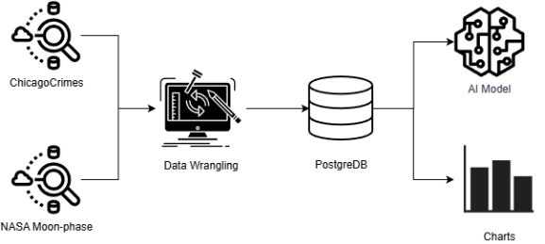
Figure 1 - Data Process Diagram

Moon-phases Dataset
For the extraction of the moon data the Liberation NASA dataset was chosen, because it is a well know, well documented source with high scientific accuracy and offers a broad range of possible relevant information, such as the moon diameter, phasing and distance from earth. Additionally, it also originates from the United States, same country as Chicago, making correlation between the datasets more consistent and reliable [5]

Fetching Data
The NASA Liberation dataset provides annual Moon data in JSON format, with each year’s data accessible via a separate URL. To compile a complete dataset for the project period (2020–2025), the six annual JSON files were downloaded, parsed, and converted into Pandas dataframes. These individual yearly dataframes were then concatenated into a single unified dataset for further analysis.

Data wrangling
Although NASA offers a already well-structured data, some transformation and cleaning were still necessary to make it more suitable for the study. From the original source, some columns were dropped, with the following columns being kept:
- time
- year
- age
- phase
- diameter
- distance
The resulting columns were further filtered with only the first observation of each day, corresponding to 00:00:00, being retained, in order to ensure a consistent one-record-per-day dataset without hourly fluctuations that are not central to the study.
Finally, a custom function was applied to the daily dataframe adding a descriptive label regarding the lunar phase, derived from the lunar age values. After all steps above, the resultant 2191 rows were uploaded in the local Postgres database.

Chicago Crimes Dataset
The Chicago crimes dataset was chosen as the dataset to base the crime statistics for the project, because it possesses a high degree of quality and a well-documented public API, allowing for easy programmatic access. Moreover, the crimes entries are recorded hourly, offering a suitable basis for integrating with the lunar phase datasets.

Fetching Data
The data set was downloaded via an official API to the Chicago Data Portal. The data were filtered to include only records from the year 2020 onward to provide a good temporal match with the other data sets in the project. Besides, the default API limits the fetch requests to 1000 entries, so an explicit limit filter of 5 million record was added to bypass this limitation.

Data wrangling
The first preprocessing step undertaken was analysing all attributes available and selecting only those fields that were of essence to the objectives. This included the following columns:
- date
- primary_type
- location_description
- arrest
- domestic
The dataset also underwent trough a normalization process on the date column to ensure a consistent temporal granularity with that used for the traffic and lunar datasets..
The subsequent wrangling step ensured consistency of format, removed any discrepancies, and standardized any variation in crime type labels. This transformation was necessary both to reduce noise and to ensure that reliable analysis of categorical values was possible.
The most challenging preprocessing step concerned the location_description field. The main reason being the fact that this field was composed of a large number of highly granular categories. The function to clean this field consisted of a standardized format and aggregation into larger and analytically meaningful groups, enhancing readability, improving reliability and further reducing sparsity.
Finally, after all cleaning, normalisation and transformation had been done, the processed dataset was uploaded to the Postgres local database in batches of 5,000 records to avoid limitations in request size. Total records inserted were 296,852.

Data Visualization
Prior to visualization, relevant datasets were fetched and merged. To ensure methodological validity, the data were standardized, when needed, to reflect daily values instead of absolute totals. This normalization accounts for the unequal temporal division of moon phases, thereby eliminating the bias where longer phases would disproportionately reflect higher crime counts.[6]
The initial visualizations consisted of regression plots examining the correlation between the moon age (number of days since the new moon) and the total volume of daily crime. On this regression plot, the outliers were removed for clarity, moreover each dot represents a single day, while the coloured line depicts the best-fit linear relationship.[7]
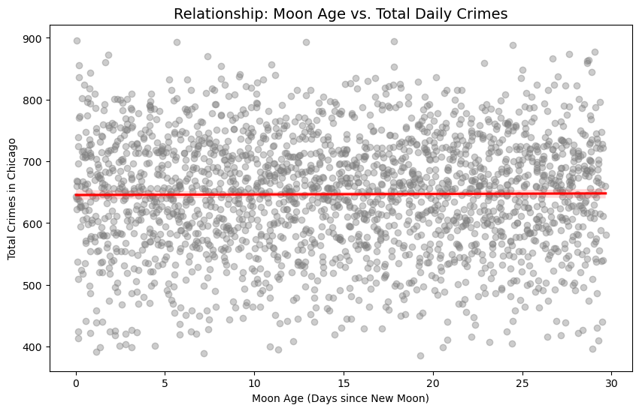
Figure 2 - Regression Plot (Moon Age x Daily Crime)
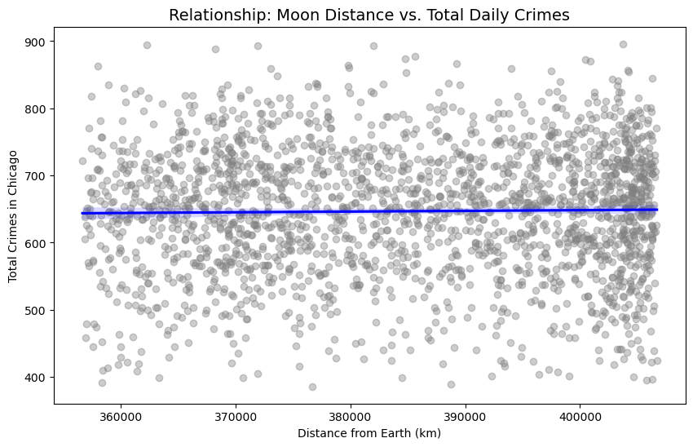
Figure 3 - Regression Plot (Moon Distance x Daily Crime)
Both charts in Figures 2 and 3 display flat regression lines, indicating no linear correlation between moon age and daily crime counts, or between lunar distance and daily crime counts in Chicago.
Even after partially debunking the myth via regression analysis, the study was further granulated by crime type, a key categorical variable in the dataset. Most crime types showed relatively no differences across moon phases.

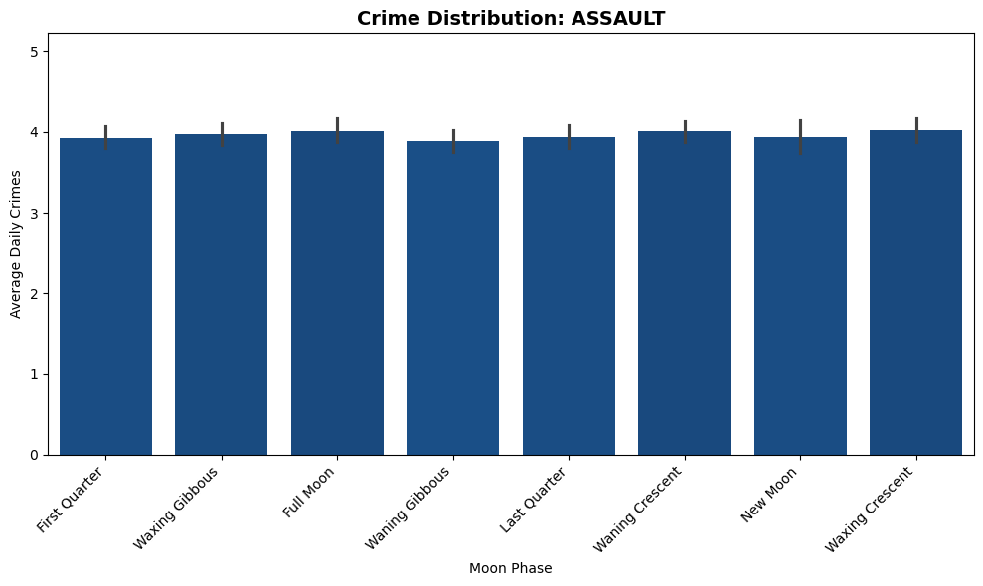
Figure 4 - Crime Distribution Assault

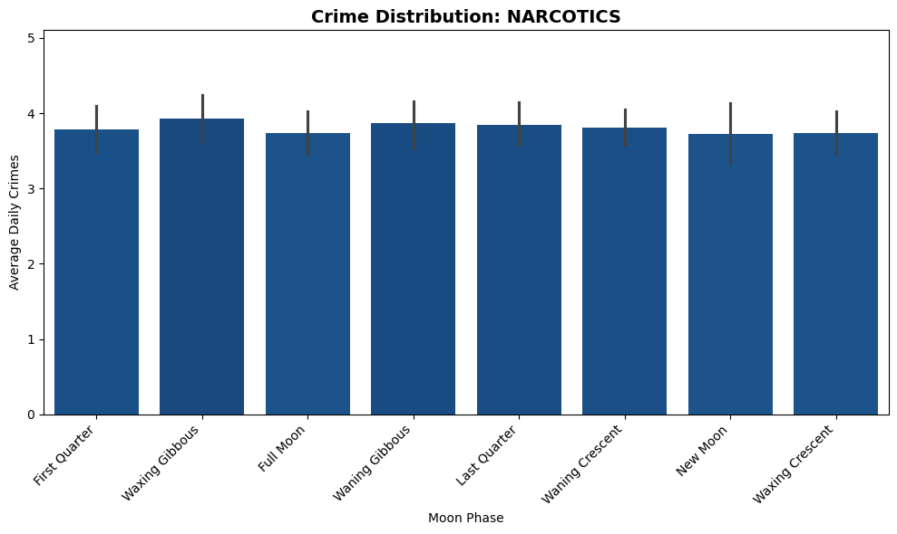
Figure 5 - Crime Distribution Narcotics

Nevertheless, certain exceptions emerged: Liquor Law Violations were more frequent during New Moons, Public Peace Violations peaked during the First Quarter, Gambling incidents were elevated during the Last Quarter, and all Ritualism cases occurred exclusively during the Waxing Crescent.

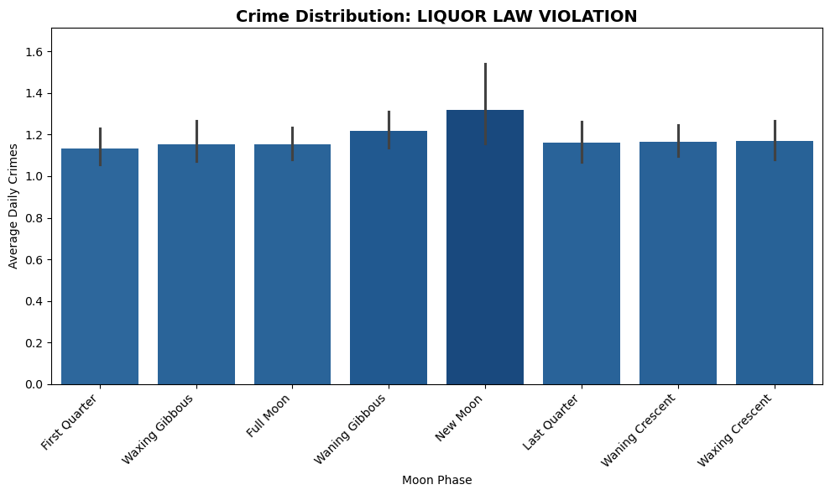
Figure 6 - Crime Distribution Liquor Law Violation

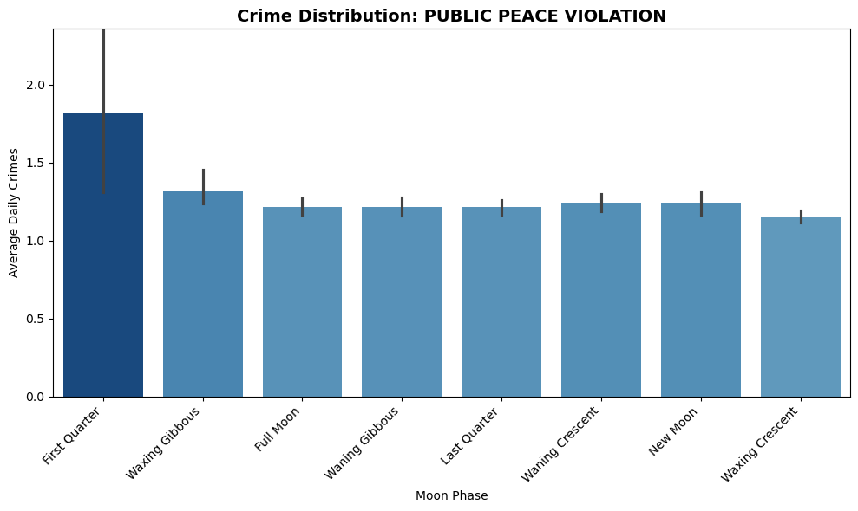
Figure 7 - Crime Distribution Public Peace Violation

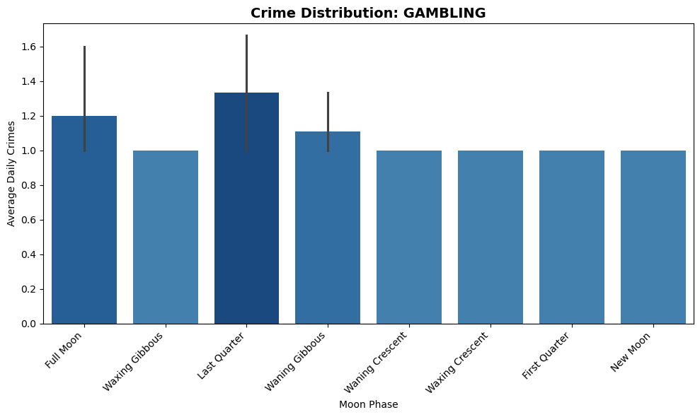
Figure 8 - Crime Distribution Gambling

Results and Evaluation

Scikit-Learn
Scikit-learn was chosen as one of the libraries for its efficient and reliable tools for cross-validation and evaluation. Also, benign is stated as a good learning library for any experimental analysis and comparative modelling. [11]

Linear Regression
The first AI model to evaluate the relationship between lunar phases and daily crime accidents, with the use of scikit-learn, was a Linear Regression. Following best practices, a five-fold cross-validation was applied to the model, where the R² (Coefficient of determination) was set as the evaluation metric. [8]
For the daily crime occurrence in the chicago_crimes dataset, the model mean R² value of -0.770 established that the model, using the moon phases, showed a substantially worse capability to preview the occurrence of daily crimes than the baseline predictor. Although some coefficients, e.g. Full Moon, exhibited a positive value, the strongly negative R² value indicates that no meaningful relationship could be raised by the model. [9]
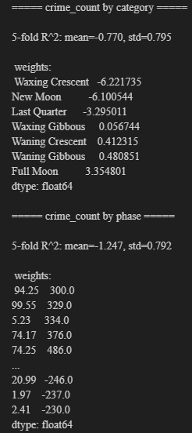
Figure 9 - Linear Regression Model Results
Overall the results indicate that the datasets do not support a linear relationship between the lunar phases and the crimes. Furthermore, the result could be the advent of a linear model's limitations of using the R² for sparse count-based data [10], which motivates the exploration of alternative models.

Random Forest
To assess the Linear Regression limitations the Random Forest models were implemented; this new model aims to capture any nonlinear relationships that cannot be captured by a Linear Regression model. With hyperparameters set to balance model stability and generalization, including a large number of estimators and minimum leaf size to reduce overfitting. [Z]
Even with the use of a more complex nonlinear model, the cross-validated R² scores remained close to or below zero for crime count. This strengths the result of the Linear Regression model, where there is no signal of a predictive capability of the moon phases for daily crimes. [9]
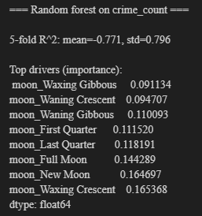
Figure 10 - Random Forest Model Results

Poisson Regression
Given that both response variables represent non-negative count data, the Poisson regression rises as an alternative. The model was determined to run using five-fold cross-validation and the mean Poisson deviance metric, as they evaluate better count-based outcomes than R². [11]
For the daily crime counts, the new model achieved the mean deviance value of 15.732, representing a moderate variability across folds. The coefficients, again, were small in magnitude, with New Moon and Full Moon showing slightly positive scores. However, these were negligible when compared to the overall variance in data. [12]
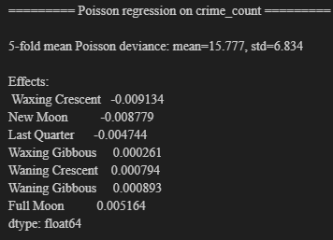
Figure 11 - Poisson Regression Results

Conclusion

References
- R. C. J. Raison, S. Klein, and A. T. Friedman, “The Moon and madness reconsidered,” Journal of Affective Disorders, vol. 93, no. 1–3, pp. 199–203, 2006.
- A. Owen, “Lunar cycles and human behaviour: Is there a link?” Psychological Reports, vol. 68, no. 3, pp. 854–856, 1991.
- J. Ratcliffe, Crime Analysis for Problem-Solvers in 60 Small Steps, U.S. Department of Justice, 2015.
- M. Abdel-Aty and A. Haleem, “Analyzing traffic crashes using multivariate statistical methods,” Accident Analysis & Prevention, vol. 42, no. 4, pp. 1407–1414, 2010.
- E. Wright, “Moon Phase and Libration, 2021-2025,” NASA Scientific Visualization Studio, 2025. [Online]. Available: https://svs.gsfc.nasa.gov.
- W. McKinney, “Data structures for statistical computing in python,” Proceedings of the 9th Python in Science Conference, vol. 445, pp. 51–56,2010.
- G. Van Rossum and F. L. Drake, The Python Language Reference, Python Software Foundation, 2024.
- DataCamp. “K-Fold Cross Validation in Machine Learning: A Practical Guide,” 2024. Available: https://www.datacamp.com/tutorial/k‐fold‐cross‐validation
- T. Hastie, R. Tibshirani, and J. Friedman, *The Elements of Statistical Learning: Data Mining, Inference, and Prediction*, 2nd ed. New York, NY, USA: Springer, 2009.
- Quantics, “Why R² is not a measure of goodness-of-fit,” 2022. Available: https://www.quantics.co.uk/blog/r-we-squared-yet-why-r-squared-is-a-poor-metric-for-goodness-of-fit/
- A. Géron, *Hands-On Machine Learning with Scikit-Learn, Keras, and TensorFlow: Concepts, Tools, and Techniques to Build Intelligent Systems*, 2nd ed., O’Reilly, 2019.
- P. McCullagh and J. A. Nelder, *Generalized Linear Models*, 2nd ed. London, UK: Chapman & Hall, 1989.

